Key Instant Recall Facts
Reception – Summer 2

I can recite the number names in order to 20.
I know doubles up to 5 + 5.
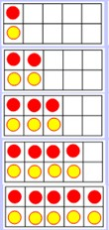
By the end of this half term, children should be able to say the number names in order to 20. The aim is for them to say the number instantly when they see that number too. They should also be able to recall the following 5 doubles.

Children should be able to start at one and then count on:  1 2 3 4 5  6 7 8 9 10  11 12 13 14  15 16 17 18  19 20  Ask them to count a set of objects and touch them as they count. Check they can say one number for one object. | If confident they could try counting backwards too: https://www.youtube.com/watch?v  =ShqXL-zfLxY – Counting backwards song.  http://www.softschools.com/counti ng/ games/counting_backwards  _from_20/ - Counting backwards game | Children should know the following doubles automatically:  1 + 1 = 2  2 + 2 = 4  3 + 3 = 6  4 + 4 = 8  5 + 5 = 10
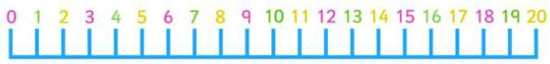

The aim is for them to recite the numbers in order and be able to recognise them when they see them.
Top Tips
Use practical resources – Your child has some sweets in front of them. Can they touch count them up to 20? Can they use real life objects to create doubles, e.g. 2 biscuits + 2 biscuits = 4 biscuits

Make a poster – We use Numicon at school. You can find pictures of the Numicon shapes here: bit.ly/NumiconPictures – your child could make a poster showing the numbers up to 20. They could use these to create a doubles poster.
Play games –
https://www.topmarks.co.uk/ordering-and-sequencing/caterpillar-ordering https://www.topmarks.co.uk/maths-games/5-7-years/sequencing-numbers http://www.snappymaths.com/counting/counting2/counting2.htm

