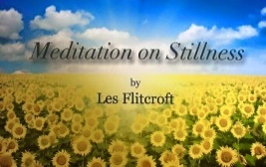
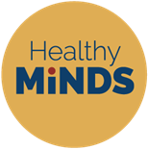
Healthy Minds Online Relaxation sessions

Healthy Minds offers relaxation sessions within schools, the community and charitable organisations.
With most children unable to go into school and out of their normal routines, they may be feeling worried and unsure at this time.
Come and join our free online relaxation/meditation sessions, suitable for children aged 4 - 11 years: Mondays: 1.00pm - 1.30pm Wednesdays: 3.00pm - 3.30pm Fridays: 10.00am - 10.30am
These sessions can help: * increase happiness * achieve calmness * focus on positive thoughts
Parents/carers/teachers welcome to join in.
Please download the Zoom App for smart phones or for PC visit http://www.zoom.us to set up a free account.
To join each week, please see the following Zoom Meeting ID:
Mondays: 1.00pm - 1.30pm Wednesdays: 3.00pm - 3.30pm Fridays: 10.00am - 10.30am ID: 954 - 3050 - 7064 ID: 913 - 9474 - 5914 ID: 971 - 2200 - 1623

To receive the Zoom access password, if you have any questions or would like more information, please contact: info@healthyminds.org.uk

We look forward to seeing you there.
Healthy Minds Team
Romi Mandozzi Lisa Willis 07812 791783 07908 591682 Director Director
Email: info@healthyminds.org.uk Website Facebook Twitter Instagram
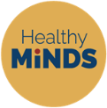
“Healthy Minds is passionate about enriching the lives of all children and young people, teaching them well-being for life tools and techniques, to carry them through their adult lives”

Healthy Minds for Healthy Futures Ltd Company Registration Number: 12318110 Registered Office: Suite 1B, 18 Crendon Street, High Wycombe, Buckinghamshire, HP13 6LS
Copyright © 2020 Healthy Minds for Healthy Futures Ltd, All rights reserved.
To view Healthy Minds Privacy Policy, please visit: https://www.healthyminds.org.uk/privacy-cookies-policy

